Windows Server Hardening
Windows Server Hardening Security Checklist:
- User Configuration: to protect our credentials.
- Network Configuration: establish communication.
- Update Installation: to patch vulnerabilities.
- Firewall Configuration: to minimize our external footprint.
- Service Configuration: to minimize our attack surface.
- Logging and Monitoring
- Remote Desktop Protocol (RDP) Hardening
- NTP (Time Synchronization) Configuration

Linux Server Hardening
Linux system hardening is the process of securing a Linux operating system by reducing vulnerabilities, minimizing attack surfaces, and enforcing security policies. This report documents the steps performed to harden a Linux system, focusing on system updates, firewall configuration, user authentication policies, and service restrictions.

1. Operating System Update
Operating System updates were performed on Ubuntu Linux to ensure the system receives the latest security patches and bug fixes. The package repository list was refreshed using APT, allowing the system to download updated package metadata from trusted Ubuntu repositories. This reduces exposure to known vulnerabilities and improves system security.

Step 1: Update package repository index
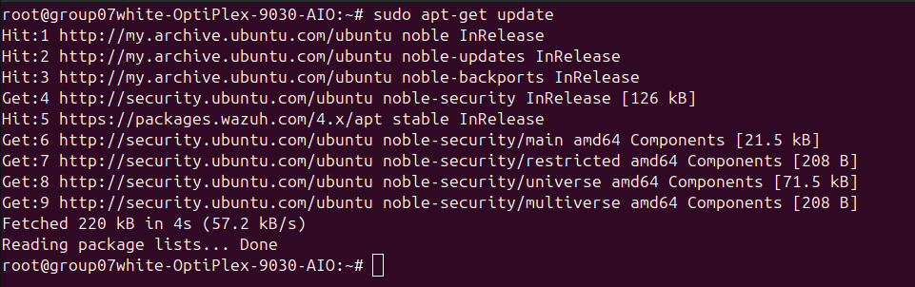

Step 2: Enable Automatic Snap Updates
To strengthen system security by enabling automatic update checks, prioritizing security updates, and ensuring long-term maintenance support is active.
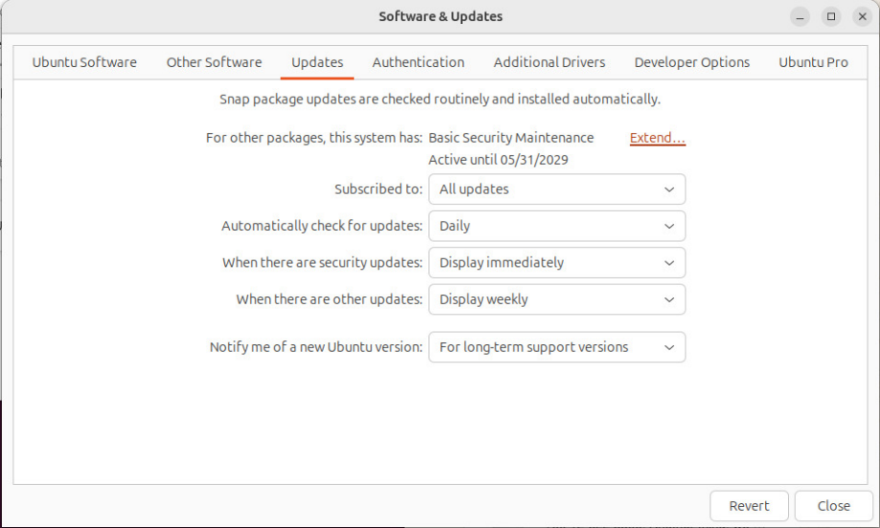

2. Controlled Privileged Access Using sudo
To restrict direct root access and enforce controlled administrative privileges using the sudo mechanism, ensuring accountability and reducing the risk of unauthorized system changes.
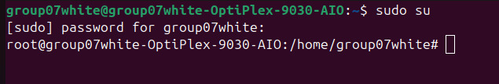

3. Uncomplicated Firewall (UFW)
Uncomplicated Firewall (UFW) was configured to control inbound and outbound network traffic. A default-deny rule was applied for incoming connections, while outgoing traffic was allowed to support normal operations such as updates and trusted communications. Only required service ports were opened, and the firewall was enabled at startup to ensure continuous protection.
Steps 1: Deny all incoming connections:
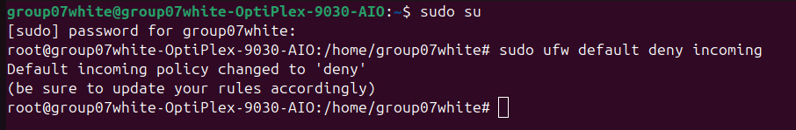

Steps 2: Allow all outgoing traffic
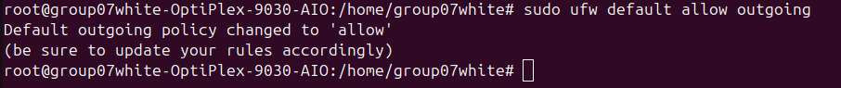
Steps 3: Allow Secure Shell (SSH) Access
Steps 4: Allow Web Traffic (HTTP and HTTPS)
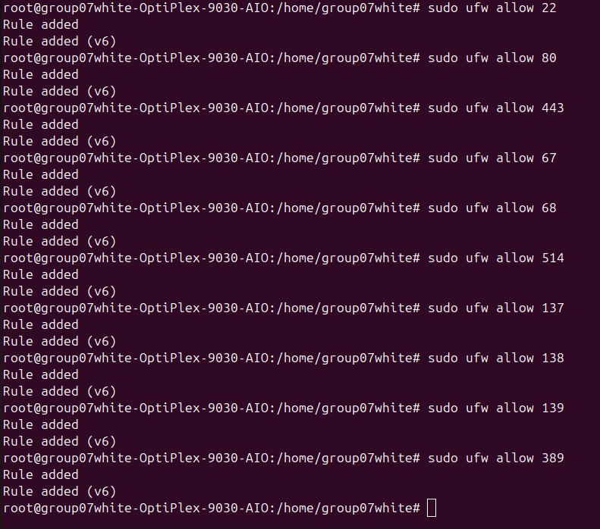
Steps 4: Enabling the UFW Firewall
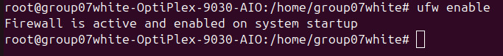
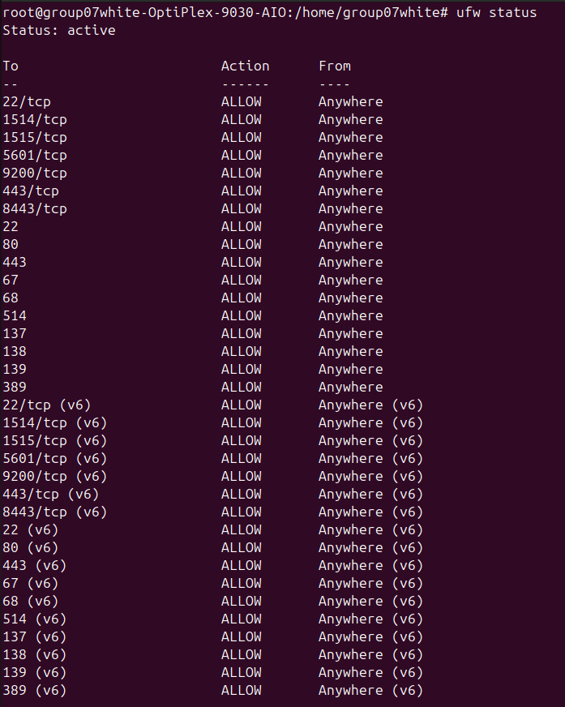

4. Password expiration controls were applied to user accounts to limit long-term password reuse. Maximum password age and warning periods were configured using the chage command. This improves account security by forcing periodic password rotation and warning users before expiration.
(i)
Steps 1: Check existing password policy
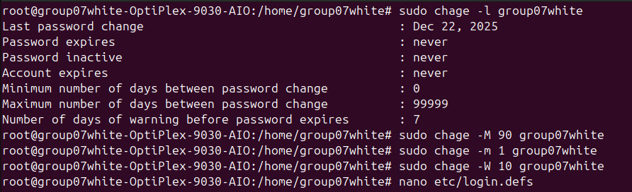
Steps 2: Set maximum password age (expire every 90 days)
Steps 3: Set minimum days between password changes
Steps 4: Set warning days before expiry
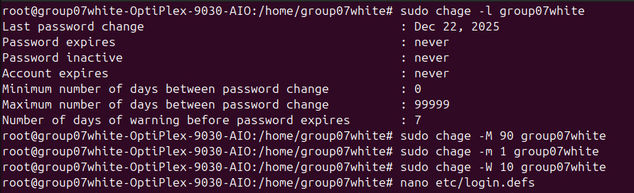
(ii) Setting Password Policy Parameters For User Accounts (System-Wide)
Step 1: Open system defaults file

Step 2: Edit password aging values
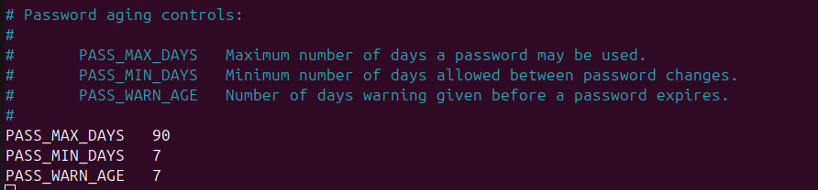
5. Disable CUPS and Close Port IPP
Step 1: Disable CUPS service auto-start (override method)
6. Disable Bluetooth
Step 1: Stop Bluetooth service immediately
Step 2: Disable Bluetooth from starting at boot
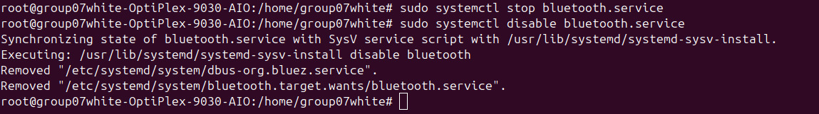
7. Enforcing Stronger Passwords
Step 1: Open PAM password policy file
Step 2: Add/verify pwquality configuration
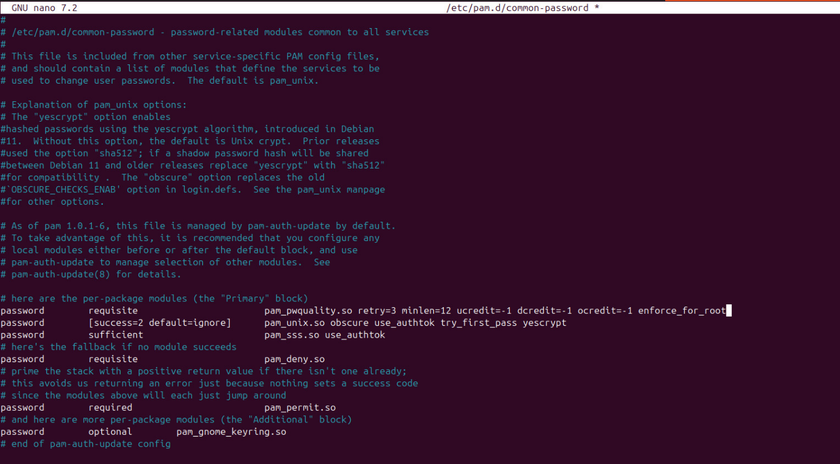

8. Lockdown Cronjobs
Step 1: Deny cron access
9. Modifying GDM Configuration with Administrative Privileges
Step 1: Open GDM configuration file
Step 2: Disable guest login
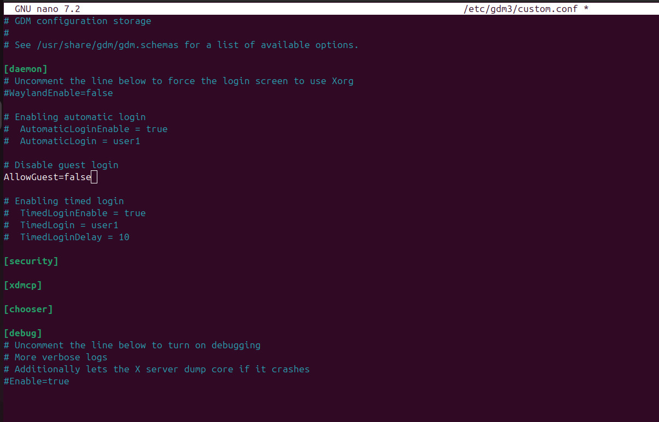

10. Disable IPv6 at Runtime
Step 1: Disable IPv6 immediately

